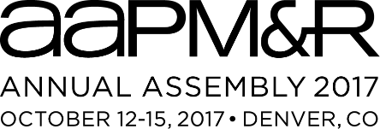
Dear Annual Assembly Faculty Member,
Thank you for serving as a faculty member at the 2017 AAPM&R Annual Assembly, October 12-15 in Denver, Colorado. We are happy to have you as one of our esteemed faculty and wish you a successful event. Our 3,000+ member physiatrists are engaged, and ready to attend your session and learn from your PM&R expertise.
In a recent Educational Needs Assessment conducted by the Academy, member respondents told us that “Quality of Faculty” was the most important factor (#1 out of 13!) in determining whether or not to attend an event. You play a significant role in the overall success of the Assembly!
Awareness of your session(s) may influence your peers’ decision to attend. As such, we’re asking for your help in promoting your session at the Assembly. Provided below is an event-related image and example social media posts. Show your support and excitement for the Assembly by using #AAPMR2017 in your posts. You can find more event details on our website: www.aapmr.org/assembly.
If there is anything we can specifically provide you, please don’t hesitate to reach out and ask. We are here to help make the 2017 Annual Assembly a valuable experience for everyone involved!
Kind regards,
Meagen Arensdorff
Director, AAPM&R Marketing Communications
marensdorff@aapmr.org | (847) 737-6092

Social Media Tools
Step 1: Find your session(s) on the agenda: https://aapmr2017.zerista.com/event. Copy the link to your session description and share it with your peers via Facebook and Twitter!
- Sample messages:
  - Check out my session <insert session title/time here> at #AAPMR2017.
  - Proud to be an #AAPMR2017 faculty member. Check out my session: <Insert link>
  - I’m speaking at #AAPMR2017, October 12-15 in Denver, Colorado. Join me by registering today!
Step 2: Use the “badge” below in your social media posts. Right-click on the image and save it to your desktop/phone photo album. Simply upload it to your favorite social media site and use the hashtag #AAPMR2017!
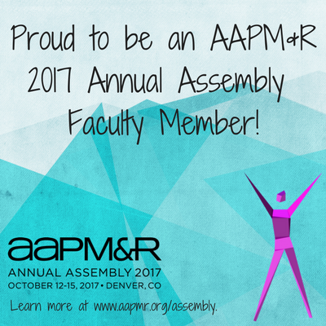
Step 3: Encourage your organization to promote your participation through their own social media and communication channels.

